**4 Inch Mini 20X IP PTZ Camera**

1. Selling Points 2

2. Brief Introduction 3

3. Features 3

4. Other Features 4

4.1. Smart Tracking 4

4.2. Get Notified with Smartphone 4

4.3. Protect Your Property at Night 5

4.4. Smart Automatically Patrol 6

4.5. Waterproof IP66 & 6000V Thunder-proof 6

4.6. Playback anytime and anywhere 7

5. What's Included? 8

6. Specification 8

7. Product Dimension 9

**Security Camera Outdoor Surveillance System PTZ 2MP 20X Zoom, Humanoid AI Auto Tracking Cruise, 100M(328ft) Night Vision IP66 Waterproof, Compact size 4inch**

**LY-E4-220**

# Selling Points

1. **H.265 Mini 4inch 1080P Pan Tilt Zoom Camera:** Compact size 4-inch mini long range IP camera, full HD 1080P video resolution with 1/2.9" CMOS, H.265 video compression saves half storage space, lower storage cost.
2. **Smart Tracking Makes Surveillance Effective:** This mini PTZ IP camera is able to distinguish between people and animals, reducing 95% false alarms caused by rain, leaves, and insects. It can automatically follow the people’s movement and intelligently return to the original guard position until the human leave monitoring area, giving your family and property more protection without missing some important details. Meanwhile, our security camera is powered by the high speed motors to deliver enhanced smooth tracking experiences.
3. **Pan Tilt Zoom Capacity:** 0.05~100°/s; PTZ range: Horizontal:0~360°, Vertical:-5~90°, 4.7~94mm lens, 20x Optical Zoom.
4. **Night Vision Day/Night Switch:** Intelligent Auto Switch, IR-Cut True Night Vision up to 100M(328ft). It’s able to see up to 100M(328ft) away from the camera with a switchable low beam/high beam LED set at night vision in response to different levels of zoom.
5. **Smartphone Setup & Control:** Apart from watching live view & playbacks, controlling pan tilt zoom actions, you can also remotely set/delete/call presets and view motion detection snapshots (stored in cloud server with push alarms) through the Smartviewer Pro app.

# Brief Introduction

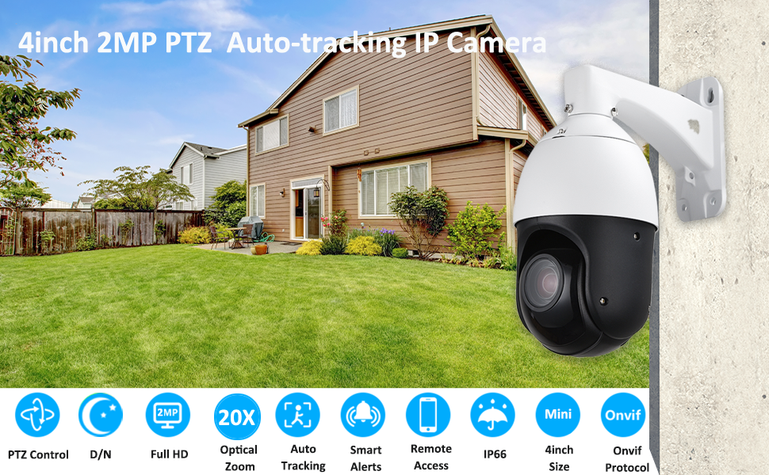

**Mini 2MP Z0X IR Auto-tracking PTZ IP Camera**

LOYALTY-SECU Mini 4 Inch 2MP Network PTZ Camera not only completely solves the short distance troubles when comparing with traditional 2.5 or 3 inch ptz camera with 50m IR distance only, but also minimizes the heavy shipping cost for overseas clients when comparing with the 6 or 8 inch ptz cameras.

The 4 Inch IP Infrared PTZ Network Camera integrates the powerful features of AI, like humanoid detection, Active Defense, Auto Tracking (high accuracy recognition of humanoid detection, intelligent alert voice to drive& auto zoom tracking), high speed pan tilt zoom ability, perfect dynamic monitoring image display, brings an excellent security experience.

# Features

1. H.265 efficient decoding for reduced bandwidth and storage space while recording
2. 2 Megapixel 1920x1080P@25fps, 960P@25fps, 1/2.9" CMOS comes with 20x optical zoom
3. High speed pan tilt zoom with 360 degrees endless horizontal rotation, -5 degrees upward tilt and 90 degrees downward movement
4. 4pcs OSRAM IR Array LEDs + 2pcs Laser LEDs, long range infrared LED night vision up to 100M(328ft)
5. Compatible with the NVR of HIKVISION, DAHUA, XM, Video park etc. and the CMS of Milestone, NUUO and AXXON platform etc.
6. Industrial-level IP66 waterproof shell with an operating temperature rating at -20～60℃ to tackle extreme weathers.

# Other Features

## Smart Tracking

Humanoid Detection + Active defense + Auto Tracking

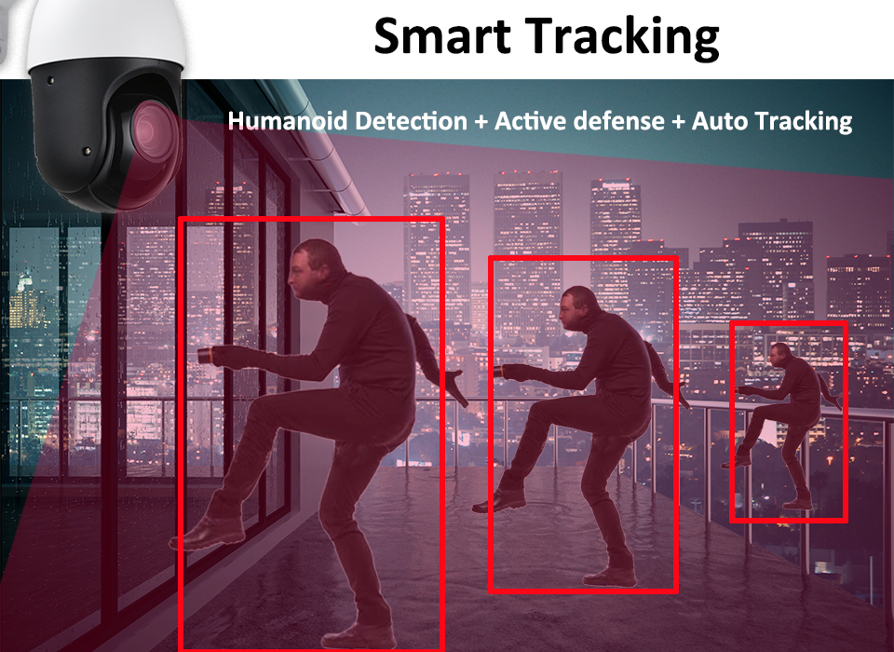

The Network PTZ dome camera supports preset position guard and cruise guard to recognize humanoid automatically. Once the detection is trigged, the security PTZ dome camera automatically turns to the target position, flashing the visible light, and the audio output line drives the live speaker to send out the voice. (If PTZ camera installed with external speaker device)

Any object enter to the intrusion area, the PTZ camera switches to the center of object immediately, security camera zooming automatically as the object moves, so the security guard can have a clear sight at the object, convenient to track the suspicious person and collect on-site digital evidence.

In order to track the target in motion and keep it in the scene all the time, our Network PTZ camera can control the pan/tilt/zoom actions accurately. Once detection is triggered, the camera can zoom in and then track the target automatically.

## Get Notified with Smartphone

Remotely watch live view & playback and control PTZ/Preset through Smartviewer Pro app (iOS & Android) with alarm message pushed.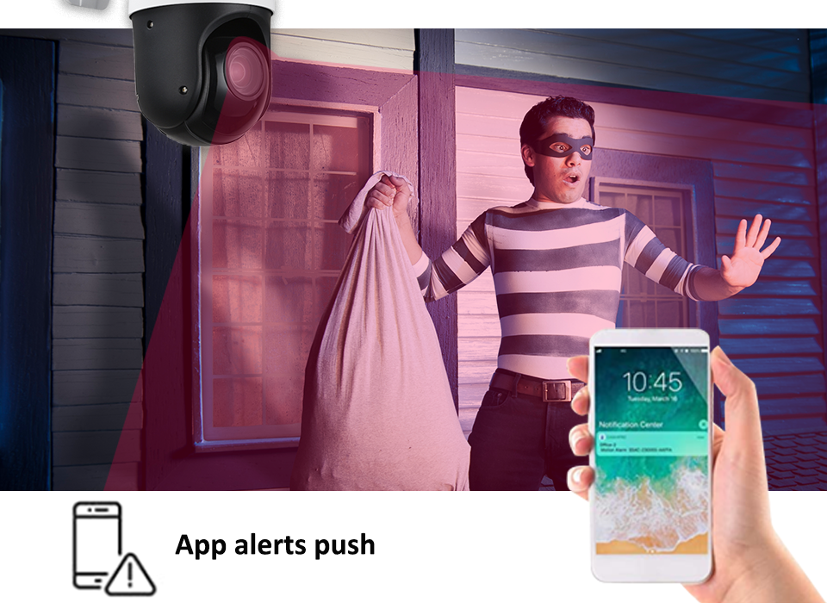

## Protect Your Property at Night

Your property will be covered by the superior night vision of LOYALTY-SECU PTZ camera with 4 pieces of IR LED. The infrared illumination distance can reach up to 100M(328ft) depending on the scene.

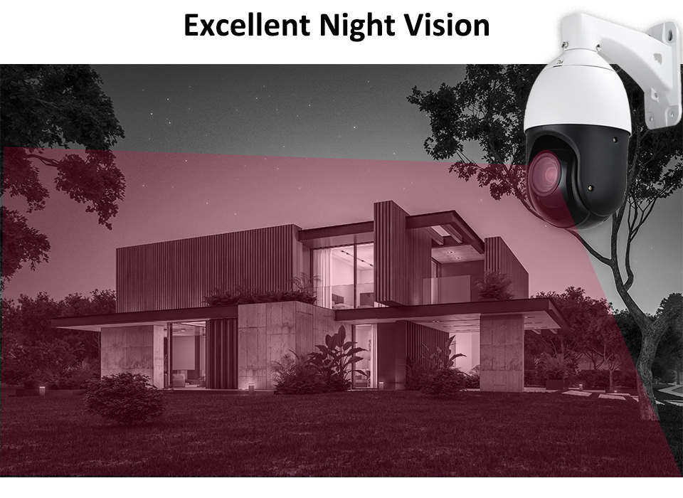

## Smart Automatically Patrol

**Support preset cruise points, time and speed-patrol in the monitoring zone you cared!**

Patrol: Up to 4 patrol groups;

Preset: 10 presets per patrol group

Patrol time: Adjustable

**Our PTZ Security Camera supports "Cruise" and "Auto Tracking" simultaneously!**

**Secure your cares through both Cruise and Auto Tracking**

1. When there is no human movement detected, the PTZ security camera will cruise according to your preset trajectory.
2. When there is human detection, this network security camera will auto tracking the human until the human disappears in the field of view. Then it will resume cruise.

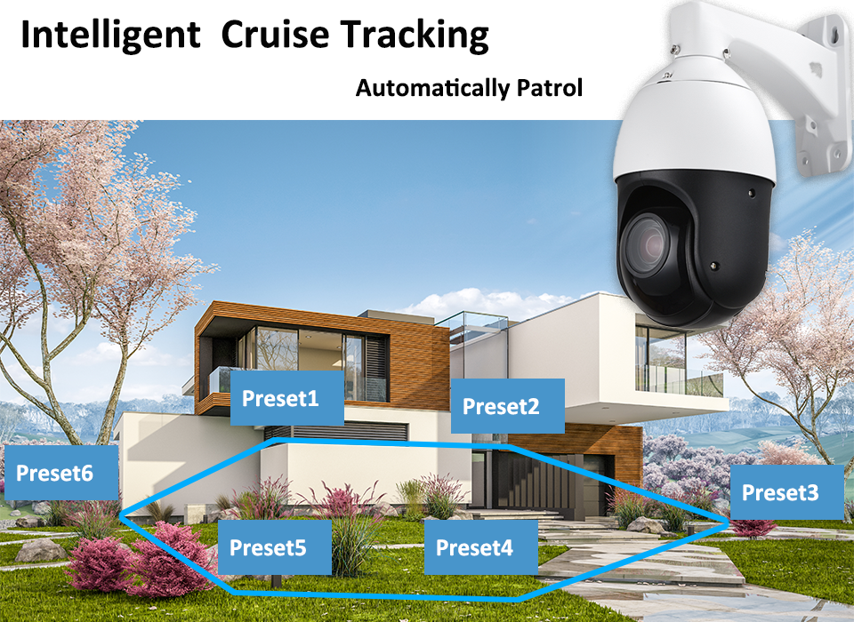

## Waterproof IP66 & 6000V Thunder-proof

The security outdoor camera is equipped with an IP66 rated weatherproof metal shell and supports **6000V Thunder-proof**, designed to operate the security PTZ camera even in some real extreme weather conditions.

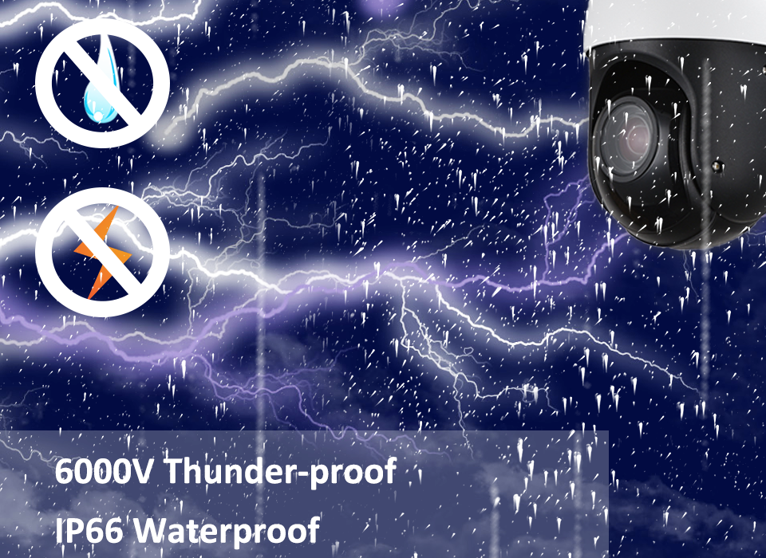

## Playback anytime and anywhere

You can play videos via your mobile phone APP at anytime and anywhere

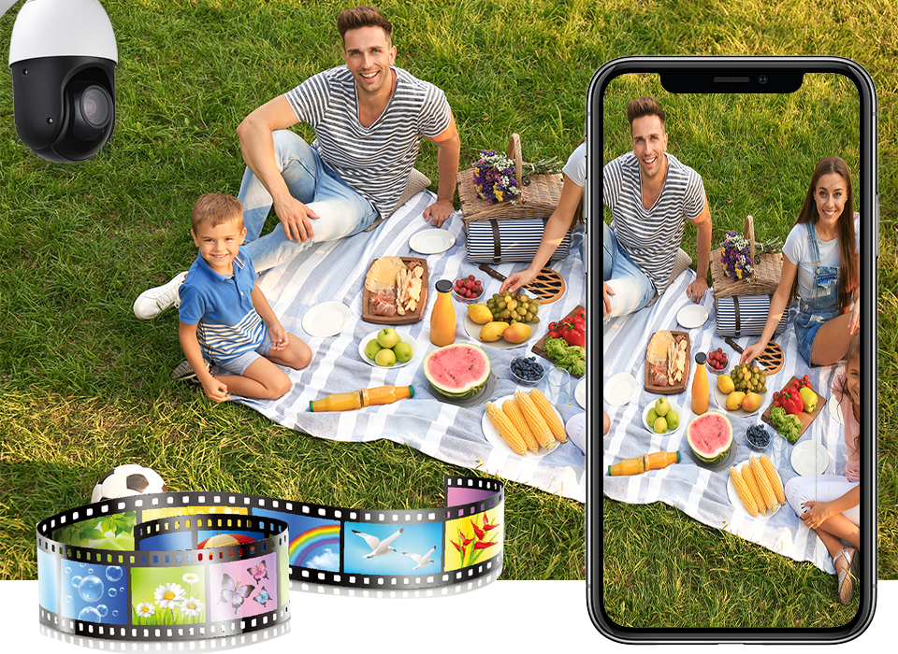

# What's Included?

Manual, Camera, Wall Bracket(default), a 12V2A Power Adapter and Installation Screws

# Specification

|  |  |
| --- | --- |
| Mini 4 Inch IP PTZ Camera | |
| Model | LY-E4-220 |
| Image Sensor | 1/2.9" CMOS |
| Camera Solution | Hi3516Ev200+GC2053 |
| Minimum Illumination | Color: 0.001Lux, B/W: 0.001Lux,0 Lux with IR |
| 3D NDR/WDR | Support |
| Electronic Shutter | AUTO |
| Day Night Mode | AUTO ICR Color to B/W |
| Focal Length: | 4.7-94mm, 20X Optical Zoom, (F1.6 to F2.7) |
| Zoom Speed | Approx.4s(Optical Wide~Tele) |
| Angle of View: | 55.4-2.9°(Wide-Tele) |
| Resolution | 1920(H)x1080(V) |
| Main Stream | 25fps:(1920×1080) (1280×960) (1280×720) |
| Sub Stream | 25fps: D1, VGA, 640×360 |
| Video Compression | H.265/H.264/MJPEG |
| TF Card | Max 128GB ( for optional) |
| Network protocol | HTTP/RTSP/RTMP/DHCP/NTP/ONVIF/NTP/UPNP/GB28181 |
| Interface protocol | ONVIF 2.5 |
| AI Functions | Humanoid Detection + Active defense + Auto Tracking |
| APP | Smartviewer Pro |
| PTZ Control | |
| IR Distance | 100M(328ft) |
| LEDs | 4PCS OSRAM IR Array LEDs + 2PCS Laser LEDs |
| Horizontal Range | 0°～360° continuously |
| Vertical Range | -5°～90° |
| Vertical/Horizontal Speed | 0.05°～100°/s |
| Max Speed | 100°/S |
| Preset | 256 |
| Patrol scan | 4groups (10 preset for each) |
| L/R Scan | 1group |
| Horizontal Scan | 1group |
| Power-off memory | Support |
| PARK Action | Watch position/ Area Scan /Horizontal 360°scan/ Cruise |
| Watch position | Support |
| Wide angle speed limit | Focus / speed automatic matching function |
| General | |
| Power/Consumption | DC12V/2A,<15W |
| Mounting | Wall mounting or lifting |
| Work environment | Temperature : -20～60℃; Humidity＜90% |
| Protection level | IP66 waterproof, 6000V lightning protection |
| Product Size | 229*132mm |
| Packing Box Size (CM) | 31*19*18CM (1PCS) |
| Packing Box Weight (KG) | 2.35KG (1 PCS) |
| Carton Size (CM) | 64*41*38CM (8 pcs in one carton) |
| Carton Weight (KG) | 19.3KG (8 PCS in a carton) |

# Product Dimension

