Loyalty-Secu Electronics Co., LTD
www.loyalty-secu.com

Add: 5th Floor,1A Building, Yunantong Industrial Park
Longhua District,Shenzhen,518109, China.
Tel: 86-755-8837 0149



4 Inch 2MP 20X AHD (4 In 1) PTZ Camera
LY-AHD-7W07

Main Features:

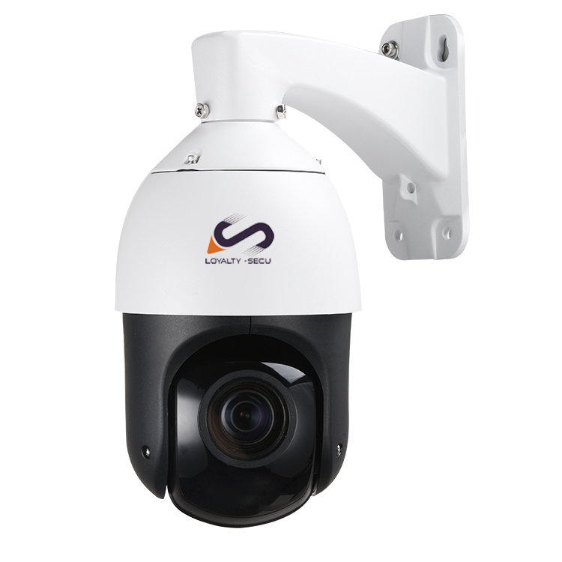
- HD 2MP/1080P ,Camera Solution: Nextchip2441+Sony307
- Lens: 20X Optical zoom, 4.7- 94mm,
- HD Over Coax Analog PTZ Camera
- 4 In 1 (AHD,HDCVI,HDTVI,CVBS)
- 4 pcs Array LEDs+ 2 pcs Laser LEDs,
IR Distance up to 100m
- Waterproof/Dustproof: IP66
- 4 Inch ,High Speed Dome
- Power Supply: 12V 2A

Highlights

4 Inch Mini AHD 4 In 1 PTZ Camera System:

- HD Over Coax Analog 1080P AHD 4 In 1PTZ Camera
- 20X Optical Zoom, can be displayed as 36X,Lens: 4.7-94mm
- 1080P AHD PTZ security camera (speed dome) with built-in infrared night vision
- Captures high definition video surveillance at 1920 x 1080 resolution (2 MP)
- 4PCS ceramic package array LEDS+2PCS laser LEDs, auto-switch to long/middle/close distance focus, IR distance up to 100m.
- Using the high accuracy stepping motor, work with the high performance motor driver, ensure the PTZ camera work under a stable, accurate, and less vibration condition.
- Support: Guard position/Power up Action /Park action/3 groups Tours /Pattern/Area scanning/360° horizontal scanning.
- All metal housing, water-proof grade: IP66,high & low temperature resistant, weather-proof
- 4-In-1 PTZ Camera -- AHD, HDCVI,HDTVI,CVBS Mode for option
- Rotating speed: Horizontal: 0.1°~100°/S ,Vertical : 0.1°~100°/S
- With 3 Groups lighting control, Infrared LEDs and focal length Auto-Matching Algorithm, adopting the Long-Mid-Near 3 group lighting design.
- Support guard tour setting, power up action, idle motion, two point scan, camera track scan, 4pcs cruise scan ,continuous 360° rotation, etc

HD Over Coax 20X AHD 4 In 1 PTZ Camera Datasheet:

Camera
Model | LY-AHD-7W07
Image Sensor | Sony307
DSP | Nextchip2441
Analog Definition | 2MP 1920 X 1080
Video System | PAL/NTSC
Minimum Illumination | Color: 0.1Lux B/W: 0.01Lux
Video Output | AHD-H(1Vp-p 75Ω)
Noise-Signal Ratio | ≥50DB
Lens | 4.7 to 94mm (F1.6 to F2.7) 20X Optical zoom
Zoom Speed | Approx.4s (Optical Wide-Tele)
Angle of View: | 55.4°-2.9° (Wide-Tele)
PTZ Control
IR Distance | 100m
Horizontal Range | -15°～360° continuously
Vertical Range | -15°～90°
Horizontal Speed | 0.05°～100°/s
Vertical Speed | 0.05°～100°/s
Max Speed | 100°/S
Preset | 256
Patrol Scan | 4pcs (10 preset for each)
L/R Scan | 1pc
Horizontal Scan | 1pc
Power-off Memory | Support
PARK Action | Watch position/ Area Scan /Horizontal 360°scan/ Cruise
Watch Position | Support
Wide Angle Speed Limit | Focus / speed automatic matching function
Analog Video Output | 1.0Vpp/75Ω,NTSC or PAL,BNC Interface
Control Interface | Support: 1. Coax cable control 2.RS485
General
Power Supply | DC12V/2A
Consumption | ＜15W
Work Environment | Temperature : -20～60℃; humidity＜90%
Protection Level | IP66 waterproof,4000V lightning protection
GW | 2.5KG

Product Dimension:

