**Loyalty-Secu Electronics Co., LTD**

[**www.loyalty-secu.com**](http://www.loyalty-secu.com)

Add: 5th Floor,1A Building, Yunantong Industrial Park

Longhua District,Shenzhen,518109, China.

Tel: 86-755-8837 0149



**4 Inch 2MP 20X AHD (4 In 1) PTZ Camera**

**LY-AHD-7W07**

**Main Features:**

* 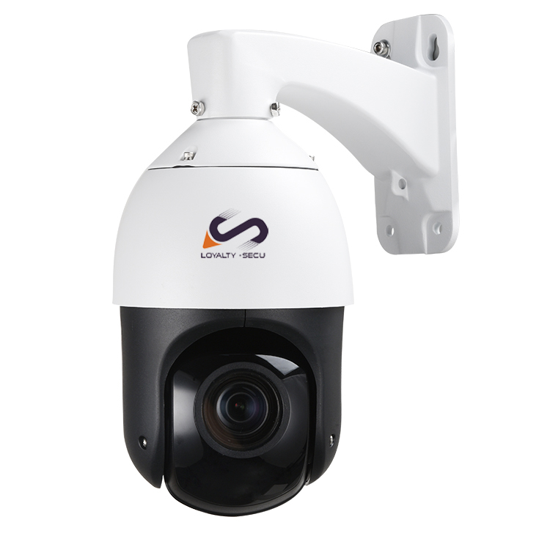**HD 2MP/1080P ,Camera Solution:** **Nextchip2441+Sony307**
* **Lens: 20X Optical zoom, 4.7- 94mm,**
* **HD Over Coax Analog PTZ Camera**
* **4 In 1 (AHD,HDCVI,HDTVI,CVBS)**
* **4 pcs Array LEDs+ 2 pcs Laser LEDs,**

**IR Distance up to 100m**

* **Waterproof/Dustproof: IP66**
* **4 Inch ,High Speed Dome**
* **Power Supply: 12V 2A**

**Highlights**

**4 Inch Mini AHD 4 In 1 PTZ Camera System:**

* HD Over Coax Analog 1080P AHD 4 In 1PTZ Camera
* 20X Optical Zoom, can be displayed as 36X,Lens: 4.7-94mm
* 1080P AHD PTZ security camera (speed dome) with built-in infrared night vision
* Captures high definition video surveillance at 1920 x 1080 resolution (2 MP)
* 4PCS ceramic package array LEDS+2PCS laser LEDs, auto-switch to long/middle/close distance focus, IR distance up to 100m.
* Using the high accuracy stepping motor, work with the high performance motor driver, ensure the PTZ camera work under a stable, accurate, and less vibration condition.
* Support: Guard position/Power up Action /Park action/3 groups Tours /Pattern/Area scanning/360° horizontal scanning.
* All metal housing, water-proof grade: IP66,high & low temperature resistant, weather-proof
* 4-In-1 PTZ Camera -- AHD, HDCVI,HDTVI,CVBS Mode for option
* Rotating speed: Horizontal: 0.1°~100°/S ,Vertical : 0.1°~100°/S
* With 3 Groups lighting control, Infrared LEDs and focal length Auto-Matching Algorithm, adopting the Long-Mid-Near 3 group lighting design.
* Support guard tour setting, power up action, idle motion, two point scan, camera track scan, 4pcs cruise scan ,continuous 360° rotation, etc

**HD Over Coax 20X AHD 4 In 1 PTZ Camera Datasheet:**

|  |  |
| --- | --- |
| **Camera** | |
| Model | LY-AHD-7W07 |
| Image Sensor | Sony307 |
| DSP | Nextchip2441 |
| Analog Definition | **2MP 1920 X 1080** |
| Video System | PAL/NTSC |
| Minimum Illumination | Color: 0.1Lux B/W: 0.01Lux |
| Video Output | AHD-H(1Vp-p 75Ω) |
| Noise-Signal Ratio | ≥50DB |
| Lens | 4.7 to 94mm (F1.6 to F2.7) 20X Optical zoom |
| Zoom Speed | Approx.4s (Optical Wide-Tele) |
| Angle of View: | 55.4°-2.9° (Wide-Tele) |
| **PTZ Control** | |
| IR Distance | 100m |
| Horizontal Range | -15°～360° continuously |
| Vertical Range | -15°～90° |
| Horizontal Speed | **0.05°～100°/s** |
| Vertical Speed | **0.05°～100°/s** |
| Max Speed | 100°/S |
| Preset | 256 |
| Patrol Scan | 4pcs (10 preset for each) |
| L/R Scan | 1pc |
| Horizontal Scan | 1pc |
| Power-off Memory | Support |
| PARK Action | Watch position/ Area Scan /Horizontal 360°scan/ Cruise |
| Watch Position | Support |
| Wide Angle Speed Limit | Focus / speed automatic matching function |
| Analog Video Output | 1.0Vpp/75Ω,NTSC or PAL,BNC Interface |
| Control Interface | Support: 1. Coax cable control 2.RS485 |
| **General** | |
| Power Supply | DC12V/2A |
| Consumption | ＜15W |
| Work Environment | Temperature : -20～60℃; humidity＜90% |
| Protection Level | IP66 waterproof,4000V lightning protection |
| GW | 2.5KG |

**Product Dimension:**

